**Create ChatBot Using Python :**

There was so many ways to create a chatbot using python. So, I used Google colab for creating a chatbot using python.

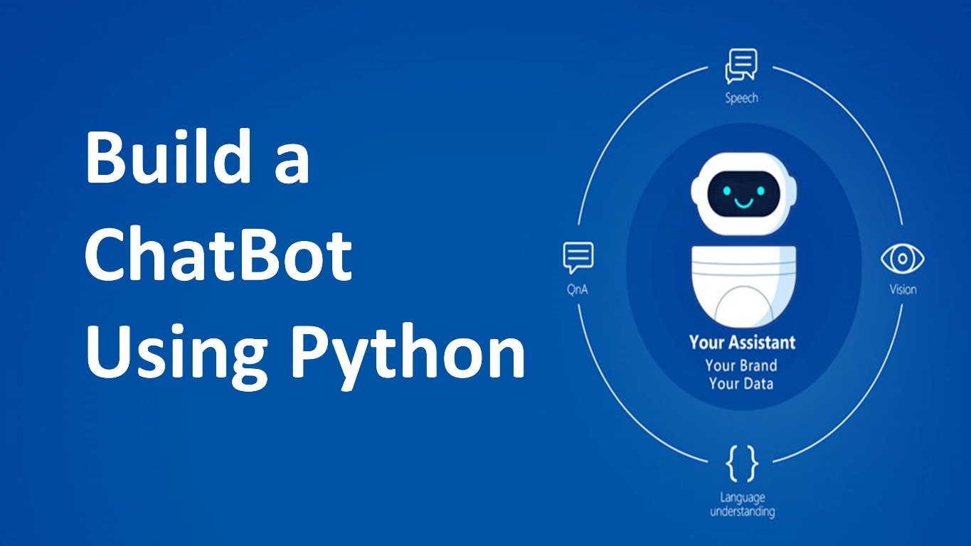

Step 1: Define the Purpose and Scope

Step 2: Choose a Framework or Library

Some popular options include:

- **NLTK (Natural Language Toolkit**)

- **spaCy**

- **Rasa**

- **Chatterbot**

- **Dialogflow**

Step 3: Set Up the Development Environment

Step 4: Install Dependencies

**pip install rasa**

Step 5: Design the Conversational Flow

Step 6: Implement Natural Language Processing (NLP)

Step 7: Implement Backend Logic

Step 8: Handle Dialog Management

Step 9: Testing the Chatbot

Step 10: Deploy the Chatbot

Step 11: Monitor and Improve

**Project Output ScreenShot :**

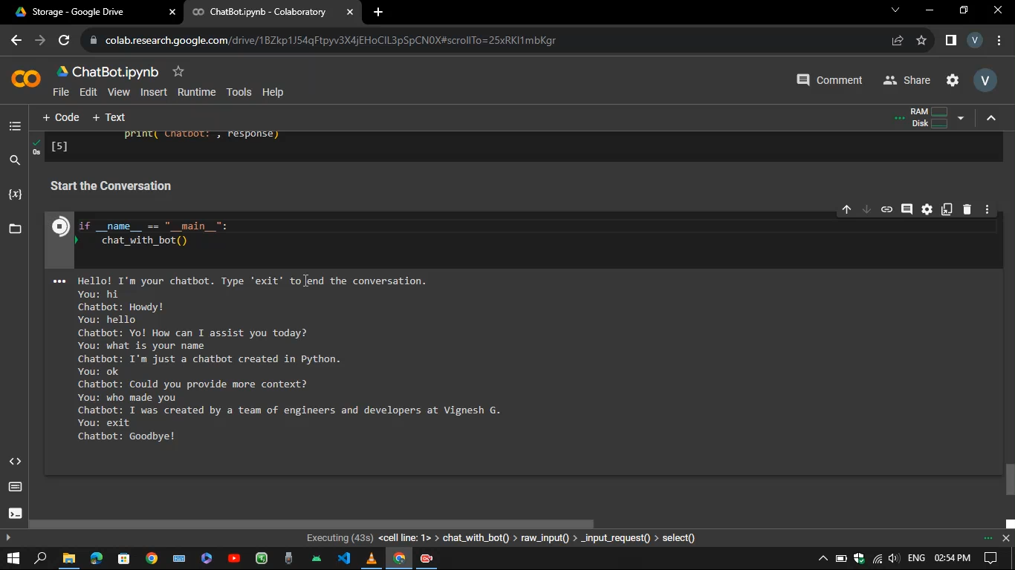

**Project Link Github :**

[*https://github.com/Sweety-Vigneshg/ChatBot-using-Python/tree/main/ChatBot%20using%20Python*](https://github.com/Sweety-Vigneshg/ChatBot-using-Python/tree/main/ChatBot%20using%20Python)

**DataSet Link :**

[*https://github.com/Sweety-Vigneshg/ChatBot-using-Python/tree/main/ChatBot%20using%20Python/Dataset*](https://github.com/Sweety-Vigneshg/ChatBot-using-Python/tree/main/ChatBot%20using%20Python/Dataset)

**Video Demo :**

[*https://github.com/Sweety-Vigneshg/ChatBot-using-Python/tree/main/ChatBot%20using%20Python/Report%20and%20Video%20Demonstration*](https://github.com/Sweety-Vigneshg/ChatBot-using-Python/tree/main/ChatBot%20using%20Python/Report%20and%20Video%20Demonstration)

**Source Code :**

[*https://github.com/Sweety-Vigneshg/ChatBot-using-Python/tree/main/ChatBot%20using%20Python/Training*](https://github.com/Sweety-Vigneshg/ChatBot-using-Python/tree/main/ChatBot%20using%20Python/Training)

*Project Submitted By*

*Vignesh G*

[*814621104059@trichyengg.ac.in*](mailto:814621104059@trichyengg.ac.in)

*Computer Science and Engineering*